PART 1 – GENERAL

1.01 SUMMARY
- Scope of work - Provide manufactured adhered veneer (units size thickness ranging from a minimum ¼” [6mm] up to a maximum 2-5/8” [65mm] and a maximum weight of 15 psf according to IBC – Chapter 14 Exterior Walls or applicable local building codes for thin adhered masonry veneer), veneer installation materials and accessories as indicated on drawings, as specified herein, and as needed for complete and proper installation.
- Related Documents - provisions within General and Supplementary General Conditions of the Contract, Division 1 - General Requirements, and the Drawings apply to this Section.

1.02 SECTION INCLUDES
- Thin adhered calcium silicate masonry units ( also referenced as thin CSMU) ARRIS▪tile Units
- Insulated Concrete Board Panels
- Installation Products; adhesives, mortars, grouts and sealants
- Air and Water Barriers

NOTE TO SPECIFIER: Edit for applicable procedures & materials

1.03 PRODUCTS FURNISHED BUT NOT INSTALLED UNDER THIS SECTION
NOTE TO SPECIFIER: Edit for applicable products

1.04 PRODUCTS INSTALLED BUT NOT FURNISHED UNDER THIS SECTION
NOTE TO SPECIFIER: Edit for applicable products

1.05 ENVIRONMENTAL PERFORMANCE REQUIREMENTS
A. Environmental Performance Criteria: The following criteria are required for products included in this section.
Refer to Division 1 for additional requirements:
1. Adhesive products must meet or exceed the VOC limits of South Coast Air Quality
Management District Rule #1168 and Bay Area Resources Board Reg. 8, Rule 51.

1.06 RELATED SECTIONS
- Section 04 01 20.91 Unit Masonry Restoration
- Section 03 03 00 Cast-in-Place Concrete
- Section 03 40 00 Precast Concrete
- Section 04 73 13 Calcium Silicate Manufactured Stone Masonry
- Section 03 03 05 Concrete Curing
- Section 03 04 10 Structural Pre-cast Concrete
- Section 04 02 00 Unit Masonry (CMU wall substrates)
- Section 04 03 00 Stone
- Section 07 01 10 Membrane Waterproofing
- Section 07 06 20 Sheet Metal flashing and Trim: Veneer Flashing
- Section 07 09 00 Joint Sealers: Perimeter sealing at Openings
- Section 07 09 20 Elastomeric Joint Sealants
- Section 09 28 13 Cementitious Backing Boards
- Section 09 28 16 Glass-Mat Faced Gypsum Backing Boards

NOTE TO SPECIFIER: Above are examples of typical broad scope and narrow scope sections related to adhered veneer installations. Edit for applicable related sections

1.07 ALLOWANCES
NOTE TO SPECIFIER: Edit for detail of applicable ALLOWANCES; coordinate with Section 01020 Allowances. Allowances in the form of unit pricing are sometimes used when the scope of the adhered veneer work at time of bid is undetermined.

1.08 ALTERNATES
NOTE TO SPECIFIER: edit for applicable ALTERNATES. Alternates may be used to evaluate varying levels of performance of setting systems or to assist in the selection of the thin adhered CSMU by economy.

1.09 REFERENCE STANDARDS
- American Iron and Steel Institute (AISI) Specification for the Design of Cold-Formed Steel Structural Members
- American National Standards Institute (ANSI) A118.1 - A118.12 American National Standard Specifications For The Installation Of Ceramic Tile
- ICC-ES AC212 - WATER-RESISTIVE COATINGS USED AS WATER-RESISTIVE BARRIERS OVER EXTERIOR SHEATHING
- American Plywood Association (APA) Y510T Plywood Design Specifications
- American Society For Testing And Materials (ASTM) C36 Standard Specification for Gypsum Wallboard
- American Society For Testing And Materials (ASTM) C482 Standard Test Method for Bond Strength of Ceramic Tile to Portland Cement
- American Society For Testing And Materials (ASTM) C847 Standard Specification for Metal Lath
- American Society For Testing And Materials (ASTM) C920 Standard Specification for Elastomeric Joint Sealants
- American Society For Testing And Materials (ASTM) C955 Standard Specification for Load Bearing (Transverse and Axial) Steel Studs, Runners (Tracks), and Bracing or Bridging for Screw Application of Gypsum Board and Metal Plaster Bases
- American Society For Testing And Materials (ASTM) E96 Standard Test Methods for Water Vapor Transmission of Materials
- Canadian Sheet Steel Building Institute (CSSBI) Lightweight Steel Framing Binder {Publication 52M}
- Metal Lath/Steel Framing Association (ML/SFA) 540 Lightweight Steel Framing Systems Manual
- Steel Stud Manufacturers Association (SSMA) Product Technical Information and ICBO Evaluation Service, Inc. Report ER-4943P
- Terrazzo, Tile And Marble Association Of Canada (TTMAC) Specification Guide 09300 Tile Installation Manual
- American Society For Testing And Materials (ASTM) C578 – Standard Specification for Rigid Cellular Polystyrene Insulation
- American Society For Testing And Materials (ASTM) D1621 – Standard Test Method for Compressive Properties of Rigid Cellular Plastics
- Tile Council Of North America (TCNA) Handbook For Ceramic Tile Installation
- ACI 530/ASCE 5/TMS 402-[___], Building Code Requirements for Masonry Structures.
- ACI 530.1/ASCE 6/TMS 602-[___], Specifications for Masonry Structures.
- ASTM C73-[___]: Standard Specification for Calcium Silicate Face Brick.

NOTE TO SPECIFIER: edit for applicable reference standards

1.10 SYSTEM DESCRIPTION
- Thin Adhered CSMU installed over [concrete masonry units] [and] [or] [poured concrete[ substrate with liquid air and water barrier, Insulated concrete board panels with drainage plane(s), latex portland cement mortar and portland cement pointing mortar.
- Thin Adhered CSMU installed over steel framing, exterior rated sheathing, liquid air and water barrier , Insulated concrete board panels with drainage plane(s), latex portland cement mortar and portland cement pointing mortar

NOTE TO SPECIFIER: The above systems are example descriptions; edit for additional applicable systems

1.11 SUBMITTALS
- Submit profile drawings and manufacturers' product data under provisions of Section (01 33 00.) (01 34 00.)
- Submit three (3) samples of each type/style/finish/size/color of adhered masonry veneer and trim unit under provisions of Section (01 00 00) (01 33 00)
- Submit manufacturers' installation instructions under provisions of Section (01 33 00.) (01 34 00.)
- Submit proof of warranty.
- Submit sample of installation system demonstrating compatibility/functional relationships between air barriers, waterproofing membranes, adhesives, mortars pointing mortars and other components under provision of Section (01 33 00.) (01 34 00.).
- For alternate materials, at least thirty (30) days before bid date submit independent laboratory test results confirming compliance with specifications listed in Part 2 - Products.

1.12 QUALITY ASSURANCE
- Adhered Masonry Veneer Manufacturer (single source responsibility): Company specializing in adhered masonry veneer, trim units with ten (10) years minimum experience. Obtain adhered masonry veneer from a single source with resources to provide products of consistent quality in appearance and physical properties.
- Installation System Manufacturer (single source responsibility): Company specializing in air barriers, waterproofing membranes, adhesive mortars, pointing mortars and other installation materials with ten (10) years minimum experience and ISO 9001 certification. Obtain installation materials from single source manufacturer to insure consistent quality and full compatibility.
- Submit positive laboratory testing to confirm applicability of air barrier, waterproofing membranes, adhesive mortars, pointing mortars, and other installation materials for specified job conditions.
- Installer qualifications: company specializing in installation of adhered masonry veneer and trim units with five (5) years documented experience with installations of similar scope, materials and design
- Insulated Concrete Board Panel Manufacturer; Company specializing in insulated concrete boards with five (5) years minimum experience. .

1.13 MOCK-UPS
- Provide mock-up of each type/style/finish/size/color of adhered masonry veneer and trim unit along with respective installation air barrier, waterproofing membranes, insulated concrete boards, adhesive mortars, pointing mortars and other installation materials, under provisions of Section (01400) (01405).

1.14 PRE-INSTALLATION CONFERENCE
- Pre-installation conference: At least three weeks prior to commencing the work attend a meeting at the jobsite to discuss conformance with requirements of specification and job site conditions. Representatives of owner, architect, general contractor, adhered masonry veneer subcontractor, adhered masonry veneer manufacturer, Installation System Manufacturer and any other parties who are involved in the scope of this installation must attend the meeting.

1.15 DELIVERY, STORAGE AND HANDLING
- Refer to Section (01 00 00) (01 60 00) (_____).
- Deliver calcium silicate masonry units in protective film. Prevent damage to units.
- Lift skids with proper and sufficiently long slings or forks with protection to prevent damage to units. Protect edges and corners.
- Store units in a manner designed to prevent damage and staining of units.
- Stack units on timbers or platforms at least 3 inches above grade.
- Place polyethylene or other plastic film between wood and other finished surfaces of units when stored for extended periods of time.
- Cover stored units with protective enclosure if exposed to weather.
- Do not use salt or calcium-chloride to remove ice from masonry surfaces.
- Store adhered masonry veneer and installation system materials in a dry location; handle in a manner to prevent chipping, breakage, and contamination.
- Protect latex additives, liquid air barriers, waterproofing membranes, epoxy adhesives and sealants from freezing or overheating in accordance with manufacturer's instructions; store at room temperature when possible.
- Store portland cement mortars and pointing mortars in a dry location.

1.16 PROJECT/SITE CONDITIONS
- Provide ventilation and protection of environment as recommended by manufacturer.
- Prevent carbon dioxide damage to adhered masonry veneer, trim, as well as adhesives, liquid air and water barrier, adhesive mortars, pointing mortars and other installation materials, by venting temporary heaters to the exterior.
- Maintain ambient temperatures not less than 37ºF (3ºC) or more than 100ºF (38ºC) during installation and for a minimum of seven (7) days after completion. Setting of portland cement is retarded by low temperatures.
  - Protect work for extended period of time and from damage by other trades.
  - Epoxy mortars and epoxy pointing mortars require surface temperatures between 60ºF (16ºC) and 90ºF (32ºC) at time of installation.
  - Liquid air barrier and waterproofing Membranes require surface temperatures between 50ºF (10ºC) and 90ºF (32ºC). It is the General Contractor’s responsibility to maintain temperature control.

NOTES FOR SPECIFIER: Edit for project specific sequence and scheduling
1.17 SEQUENCING AND SCHEDULING
- Coordinate installation of adhered masonry veneer work with related work.
- Proceed with adhered masonry veneer work only after curbs, vents, drains, piping, and other projections through substrate have been installed and when substrate construction and framing of openings have been completed.

1.18 WARRANTY
- Thin Adhered CSMU installed over poured concrete, concrete masonry units or wood or steel studs with exterior grade primary sheathing substrates when using insulated concrete board panels:
  - The Contractor warrants the work of this Section to be in accordance with the Contract Documents and free from faults and defects in materials and workmanship for a period of 15 years. The manufacturer of adhesives, liquid air and water barrier, mortars, pointing mortars and other installation materials shall provide a written fifteen (15) year warranty, which covers materials and labor - reference LATICRETE Warranty Data Sheet 230.15SPD for complete details and requirements.

1.19 EXTRA MATERIAL STOCK
- Upon completion of the work of this Section, deliver to the Owner 2% minimum additional adhered masonry veneer and trim shapes or a minimum of 2 additional pieces of each type, color, pattern and size used in the Work, as well as extra stock of adhesive mortars, pointing mortars and other installation materials for the Owner's use in replacement and maintenance.

PART 2 - PRODUCTS

2.01 MANUFACTURERS
Subject to compliance with paragraphs 1.12 and performance requirements, provide products by one of the following manufacturers:
- Manufacturers of calcium silicate masonry units having Products considered acceptable for use:
- Arriscraft International [, as distributed by [_____] ARRIS▪tile Renaissance Units].

- Substitution Procedures: refer to [Instructions to Bidders] [and] [Section [01 00 00] [01 25 00] [_____]].

- Manufacturers of Adhered Masonry Veneer Installation Materials and Accessories having Products considered acceptable for use:
- Laticrete International [, as distributed by [_____]].

- Substitution Procedures: refer to [Instructions to Bidders] [and] [Section [01 00 00] [01 25 00] [_____]].

- Manufacturers of Insulated Concrete Board Panels and Accessories having Products considered acceptable for use:
- T-Clear Inc. [, as distributed by [_____]].

- Substitution Procedures: refer to [Instructions to Bidders] [and] [Section [01 00 00] [01 25 00] [_____]].

NOTE TO SPECIFIER: Provide list of acceptable adhered masonry veneer manufacturers. Consider including the name and telephone number of a local distributor to assist bidders with product sourcing.

2.02 ADHERED MASONRY VENEER MATERIALS
NOTE TO SPECIFIER: Refer to ARRISCRAFT•DATA sheet 04 73 13 - Calcium Silicate Manufactured Stone Masonry for specific information pertaining to sizes, finishes, colors, etc. When different colors and/or textures are required, describe each instance separately with its own paragraph and designator, properly coordinated with the drawing notations.
- Thin Adhered Calcium Silicate Masonry Units (Thin Adhered CSMU) (Georgia): to ASTM C73, Grade SW; solid units that have been pressure formed and autoclaved; and then cut to [3/4”] and/or [1-3/8” (available in smooth only)] thickness; special shapes as indicated; and as follows:
  - Modular Size: [[3-5/8"] [7-5/8"] [11-5/8"] high, 23-5/8" long] [as scheduled] [as indicated on Drawings];
  - Texture: [smooth] [rocked] finish [as scheduled] on exposed faces [and ends];
  - Color: [______] color [as scheduled] [as selected by [Architect][Engineer]];Fabricate calcium silicate masonry units to the following tolerances:
  - Unit Length: plus or minus 1/16".
  - Unit Height: plus or minus 1/16".
  - Deviation From Square: plus or minus 1/16", with measurement taken using the longest edge as the base.
  - Custom Unit Dimensions: plus or minus 1/8".

2.03 INSULATED CONCRETE BOARD PANELS
NOTE TO SPECIFIER: This article includes generic descriptions of insulated concrete board product. The names of the corresponding T-Clear products follow in parenthesis. If this section is being edited to be generic, then these product names should be deleted).

NOTE TO SPECIFIER: If other manufacturers are being added to this section, then (1) add the proprietary product names of those manufacturers, or (2) if proprietary names are listed in the “Manufacturers” article above, then delete them from this article altogether.
- Insulated Concrete Board Panels: ¼” thick Utilicrete Concrete Board, that is water durable; surfaced with fiberglass reinforcing mesh on front and back and with long edges wrapped and then laminated to [Expanded Polystyrene Insulation], [Extruded Polystyrene Insulation], [Mineral Wool Insulation] (ProGUARD®DP Insulated Concrete Board) with the following properties:

NOTE TO SPECIFIER: Select only the board thickness(es) required for the project based on the desired Continuous R-value desired and number of drainage planes. Delete all other rows/thicknesses to avoid confusion

  - ProGUARD®DP Expanded Polystyrene Rigid Insulation (EPS) Insulated Concrete Board Sizes (Single Drainage Plane):

ProGUARD Insulated Concrete Board Panel Pricing (EPS Foam Insulation with Single Drainage Plane)
ProGUARD Size and thickness | Insulation Thickness | Continuous Insulation thickness (net of single 3/8" Drainage Plane) | R-value (most typical) per ASTM C-578 | R-value per ASTM C-578 | R-value per ASTM C-578
ProGUARD Size and thickness | Insulation Thickness |  | (4.35/in) @75⁰F | (4.76/in) @40⁰F | (5.00/in) @25⁰F
3'-0" x 8'-0" x 1-1/4" EPS DP-1 (Single Drainage Plane) | 1" | 5/8" | 2.72 | 2.98 | 3.13
3'-0" x 8'-0" x 1-1/2" EPS DP-1 (Single Drainage Plane) | 1-1/4" | 7/8" | 3.80 | 4.17 | 4.38
3'-0" x 8'-0" x 1-3/4" EPS DP-1 (Single Drainage Plane) | 1-1/2" | 1-1/8" | 4.89 | 5.36 | 5.63
3'-0" x 8'-0" x 2" EPS DP-1 (Single Drainage Plane) | 1-3/4" | 1-3/8" | 5.98 | 6.55 | 6.88
3'-0" x 8'-0" x 2-1/4" EPS DP-1 (Single Drainage Plane) | 2" | 1-5/8" | 7.07 | 7.74 | 8.13
3'-0" x 8'-0" x 2-1/2" EPS DP-1 (Single Drainage Plane) | 2-1/4" | 1-7/8" | 8.15 | 8.93 | 9.38
3'-0" x 8'-0" x 2-3/4" EPS DP-1 (Single Drainage Plane) | 2-1/2" | 2-1/8" | 9.24 | 10.12 | 10.63
3'-0" x 8'-0" x 3" EPS DP-1 (Single Drainage Plane) | 2-3/4" | 2-3/8" | 10.33 | 11.31 | 11.88
3'-0" x 8'-0" x 3-1/4" EPS DP-1 (Single Drainage Plane) | 3" | 2-5/8" | 11.41 | 12.50 | 13.13
3'-0" x 8'-0" x 3-1/2" EPS DP-1 (Single Drainage Plane) | 3-1/4" | 2-7/8" | 12.50 | 13.69 | 14.38
3'-0" x 8'-0" x 3-3/4" EPS DP-1 (Single Drainage Plane) | 3-1/2" | 3-1/8" | 13.59 | 14.88 | 15.63
3'-0" x 8'-0" x 4-1/4" EPS DP-1 (Single Drainage Plane) | 4" | 3-5/8" | 15.76 | 17.26 | 18.13
3'-0" x 8'-0" x 5-1/4" EPS DP-1 (Single Drainage Plane) | 5" | 4-5/8" | 20.11 | 22.02 | 23.13
3'-0" x 8'-0" x 6-1/4" EPS DP-1 (Single Drainage Plane) | 6" | 5-5/8" | 24.46 | 26.79 | 28.13

NOTE TO SPECIFIER: Select only the board thickness(es) required for the project based on the desired Continuous R-value desired and number of drainage planes. Delete all other rows/thicknesses to avoid confusion

  - ProGUARD®DP Expanded Polystyrene Rigid Insulation (EPS) Insulated Concrete Board Sizes (Double Drainage Plane):

ProGUARD Insulated Concrete Board Panel Pricing (EPS Foam Insulation with Double Drainage Plane)
ProGUARD Size and thickness | Insulation Thickness | Continuous Insulation thickness (net of double 3/8" (3/4" total) Drainage Planes) | R-value (most typical) per ASTM C-578 | R-value per ASTM C-578 | R-value per ASTM C-578
ProGUARD Size and thickness | Insulation Thickness |  | (4.35/in) @75⁰F | (4.76/in) @40⁰F | (5.00/in) @25⁰F
3'-0" x 8'-0" x 1-3/4" EPS DP-2 (Double Drainage Plane) | 1-1/2" | 3/4" | 3.26 | 3.57 | 3.75
3'-0" x 8'-0" x 2" EPS DP-2 (Double Drainage Plane) | 1-3/4" | 1" | 4.35 | 4.76 | 5.00
3'-0" x 8'-0" x 2-1/4" EPS DP-2 (Double Drainage Plane) | 2" | 1-1/4" | 5.43 | 5.95 | 6.25
3'-0" x 8'-0" x 2-1/2" EPS DP-2 (Double Drainage Plane) | 2-1/4" | 1-1/2" | 6.52 | 7.14 | 7.50
3'-0" x 8'-0" x 2-3/4" EPS DP-2 (Double Drainage Plane) | 2-1/2" | 1-3/4" | 7.61 | 8.33 | 8.75
3'-0" x 8'-0" x 3" EPS DP-2 (Double Drainage Plane) | 2-3/4" | 2" | 8.70 | 9.52 | 10.00
3'-0" x 8'-0" x 3-1/4" EPS DP-2 (Double Drainage Plane) | 3" | 2-1/4" | 9.78 | 10.71 | 11.25
3'-0" x 8'-0" x 3-1/2" EPS DP-2 (Double Drainage Plane) | 3-1/4" | 2-1/2" | 10.87 | 11.90 | 12.50
3'-0" x 8'-0" x 3-3/4" EPS DP-2 (Double Drainage Plane) | 3-1/2" | 2-3/4" | 11.96 | 13.10 | 13.75
3'-0" x 8'-0" x 4-1/4" EPS DP-2 (Double Drainage Plane) | 4" | 3-1/4" | 14.13 | 15.48 | 16.25
3'-0" x 8'-0" x 5-1/4" EPS DP-2 (Double Drainage Plane) | 5" | 4-1/4" | 18.48 | 20.24 | 21.25
3'-0" x 8'-0" x 6-1/4" EPS DP-2 (Double Drainage Plane) | 6" | 5-1/4" | 22.83 | 25.00 | 26.25

NOTE TO SPECIFIER: Select only the board thickness(es) required for the project based on the desired Continuous R-value desired and number of drainage planes. Delete all other rows/thicknesses to avoid confusion

  - ProGUARD®DP Extruded Polystyrene Rigid Insulation (XPS) Insulated Concrete Board Sizes (Single Drainage Plane):

ProGUARD Insulated Concrete Board Panel Pricing (XPS Foam Insulation with Single Drainage Plane)
ProGUARD Size and thickness | Insulation Thickness | Continuous Insulation thickness (net of single 3/8" Drainage Plane) | R-value
ProGUARD Size and thickness | Insulation Thickness |  | (5.00/in) @75⁰F
3'-0" x 8'-0" x 1-3/4" XPS DP-1 (Single Drainage Plane) | 1-1/2" | 1-1/8" | 5.63
3'-0" x 8'-0" x 2-1/4" XPS DP-1 (Single Drainage Plane) | 2" | 1-5/8" | 8.13
3'-0" x 8'-0" x 2-3/4" XPS DP-1 (Single Drainage Plane) | 2-1/2" | 2-1/8" | 10.63
3'-0" x 8'-0" x 3-1/4" XPS DP-1 (Single Drainage Plane) | 3" | 2-5/8" | 13.13
3'-0" x 8'-0" x 4-1/4" XPS DP-1 (Single Drainage Plane) | 4" | 3-5/8" | 18.13

NOTE TO SPECIFIER: Select only the board thickness(es) required for the project based on the desired Continuous R-value desired and number of drainage planes. Delete all other rows/thicknesses to avoid confusion

  - ProGUARD®DP Extruded Polystyrene Rigid Insulation (XPS) Insulated Concrete Board Sizes (Double Drainage Plane):

ProGUARD Insulated Concrete Board Panel Pricing (XPS Foam Insulation with Double Drainage Plane)
ProGUARD Size and thickness | Insulation Thickness | Continuous Insulation thickness (net of double 3/8" (3/4" total) Drainage Planes) | R-value
ProGUARD Size and thickness | Insulation Thickness |  | (5.00/in) @75⁰F
3'-0" x 8'-0" x 1-3/4" XPS DP-2 (Double Drainage Plane) | 1-1/2" | 3/4" | 3.75
3'-0" x 8'-0" x 2-1/4" XPS DP-2 (Double Drainage Plane) | 2" | 1-1/4" | 6.25
3'-0" x 8'-0" x 2-3/4" XPS DP-2 (Double Drainage Plane) | 2-1/2" | 1-3/4" | 8.75
3'-0" x 8'-0" x 3-1/4" XPS DP-2 (Double Drainage Plane) | 3" | 2-1/4" | 11.25
3'-0" x 8'-0" x 4-1/4" XPS DP-2 (Double Drainage Plane) | 4" | 3-1/4" | 16.25

NOTE TO SPECIFIER: Select only the board thickness(es) required for the project based on the desired Continuous R-value desired. Delete all other rows/thicknesses to avoid confusion

  - ProGUARD®DP Mineral Wool Insulation (6 lbs Density) Insulated Concrete Board Sizes:

ProGUARD Insulated Concrete Board Panel Pricing (Mineral Wool Insulation with No Drainage Planes - Drainage planes are not required as mineral wool is free draining)
ProGUARD Size and thickness | Insulation Thickness | R-value
ProGUARD Size and thickness | Insulation Thickness | (4.3/in) @75⁰F
3'-0" x 4'-0" x 1-1/4" DP-0 (No Drainage Plane) | 1" | 4.30
3'-0" x 4'-0" x 1-3/4" DP-0 (No Drainage Plane) | 1-1/2" | 6.45
3'-0" x 4'-0" x 2-1/4" DP-0 (No Drainage Plane) | 2" | 8.60
3'-0" x 4'-0" x 2-3/4" DP-0 (No Drainage Plane) | 2-1/2" | 10.75
3'-0" x 4'-0" x 3-1/4" DP-0 (No Drainage Plane) | 3" | 12.90
3'-0" x 4'-0" x 3-3/4" DP-0 (No Drainage Plane) | 3-1/2" | 15.05
3'-0" x 4'-0" x 4-1/4" DP-0 (No Drainage Plane) | 4" | 17.20
3'-0" x 4'-0" x 5-1/4" DP-0 (No Drainage Plane) | 5" | 21.50
3'-0" x 4'-0" x 6-1/4" DP-0 (Double Drainage Plane) | 6" | 25.80

  - Concrete Board Edges: Tapered.
  - Compressive Strength of Concrete Board: not less than 2600 lbs. per sq. in. when tested in accordance with ASTM D 2394.
  - Flexural Strength of Concrete Board: not less than 1500 lbs. per sq. in. when tested in accordance with ASTM C 947.
  - Surface Burning Characteristics of Concrete Board:
    - Flame Spread – 5 when tested in accordance with ASTM – E84
    - Smoke Developed – 0 when tested in accordance with ASTM – E85
  - Density of Expanded Polystyrene Rigid Insulation not less than 1.8 lbs. per c.f.
  - Water Absorption of Expanded Polystyrene Rigid Insulation not more than 2% by volume
  - Expanded Polystyrene Rigid Insulation to meet ASTM C 578 – 08b Type IX
  - Finished edges of insulated concrete board panels to be ship lapped

NOTE TO SPECIFIER: Steel stud screw length should be selected so that the screw can penetrate the entire thickness of the Insulated Concrete Board Panels and the exterior sheathing without breaking the exterior skin of the cement board and achieve a minimum one-inch (1”) embedment into the steel studs

- [ProGUARD®DP Steel or Wood Stud Fasteners:]
  - Stud Screws: Drill & Tap up to 16 Gauge Steel Stud, Concealor Self Drill Screws with Pancake Head and Tri-Seal Coated
    - Diameter: DP#1 - 5/8”
    - Length: [1-1/2”], [2”], [3”], [4”], [4-1/2”], [ 5”], [6”], [7”], [8”]
[and],

NOTE TO SPECIFIER: Concrete Masonry (CMU), Poured Concrete, or Masonry screw length should be selected so that the screw can penetrate the entire thickness of the Insulated Concrete Board Panels without breaking the exterior skin of the cement board and with a minimum one-inch (1”) embedment into the concrete substrate
- [ProGUARD®DP Concrete or Masonry Fasteners:]
  - Concrete Masonry, Poured Concrete, or Masonry Screws: Sentry Plus Five Screws with Truss Head and Epoxy Coated
    - Length: [#14 x -1-1/2"], [#14 x 2"], [#14x2-1/2"], [#14x3"], [#14x3-1/2"], [#14x4"], [#14x4-1/2"], [#14x5"], [#14x5-1/2"], [#14x6"], [#14x7"], [#14x8"\

- Screw Spacing: Engineer of Record to select the screw spacing based on the worst case scenario based on the below three requirements supported panels, unsupported panels and wind pressure:
    - Unsupported Panel Application (where the screws will support the weight of the veneer, ProGUARD®DP panels and Laticrete Mortar). Reference the below NTA report. The Engineer of Record to calculate the screw spacing based on the weight of the veneer, ProGUARD®DP panels (3 psf) and Laticrete Mortar (1.5 psf).

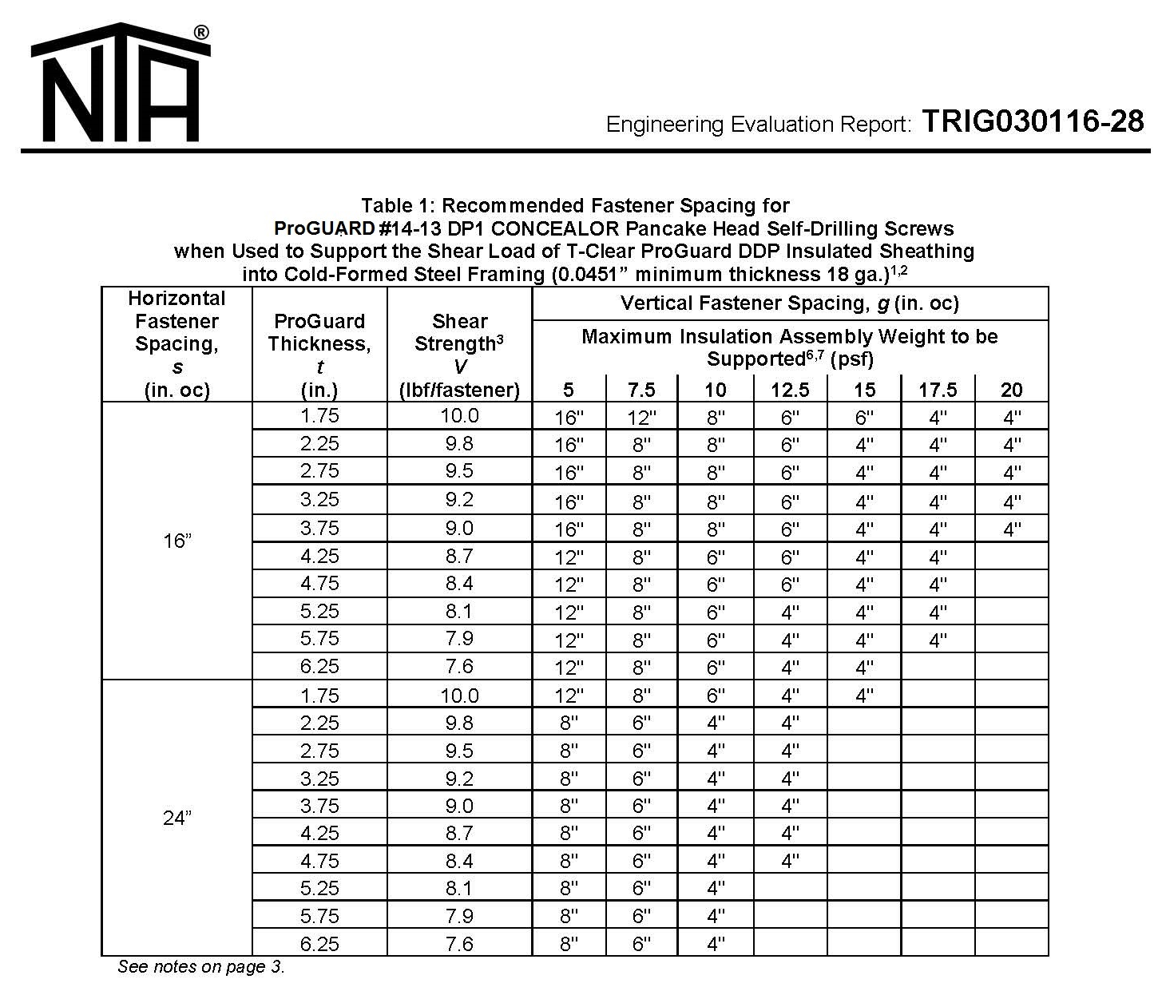

    - Supported Panel Application (where the screws and the 16 GAUGE Steel Flashing/Support or foundation ledge will support the weight of the veneer, ProGUARD®DP panels and Laticrete Mortar). Reference the below NTA report. The Engineer of Record to calculate the height of the wall between support levels and screw spacing based on the weight of the veneer, ProGUARD®DP panels (3 psf) and Laticrete Mortar (1.5 psf).

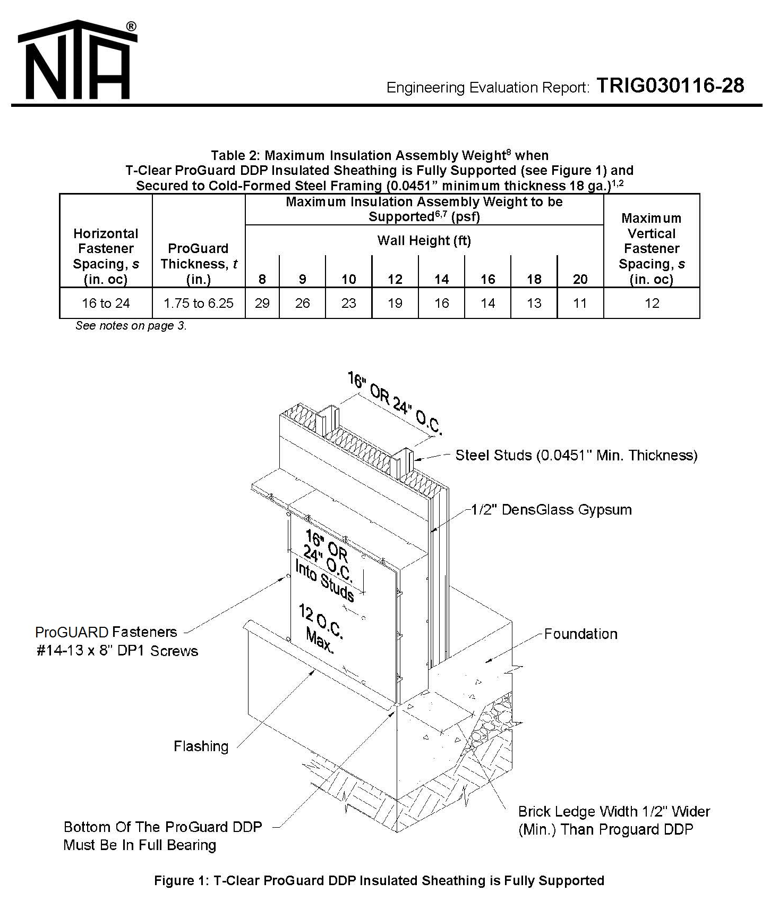

    - Screw Spacing based on anticipated Wind Loads. Reference the below NTA report. The Engineer of Record to calculate the screw spacing based on the anticipated wind pressure and the weight of the veneer, ProGUARD®DP panels (3 psf) and Laticrete Mortar (1.5 psf).

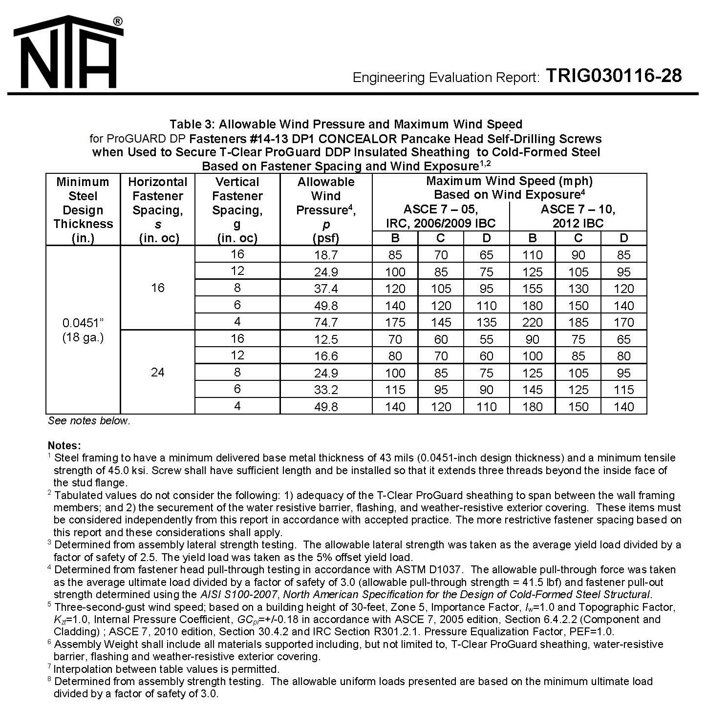

- Joint Treatment:
  - Tape: minimum 4” ProGUARD®DP Blue Alkali-resistant fiberglass mesh tape intended for use with concrete board.

- Joint Mudding Materials:
  - Latex Portland Cement Mortar: LATICRETE Hi-Bond Masonry Veneer Mortar ** to be weather, frost, shock resistant, non-flammable and meet the following physical requirements:
    - Compressive strength (ANSI A118.4): >2500 psi (17.2 MPa)
    - Bond strength (ANSI A118.4): >450 psi (3.1 MPa)
    - Smoke & Flame Contribution (ASTM E84 Modified): 0
    - Total VOC Content: < 0.05 mg/m³

2.04 ADHERED MASONRY VENEER INSTALLATION MATERIALS AND ACCESSORIES
- [Air and Water (and Vapor) Barrier Membrane: LATICRETE® Air & Water Barrier ** to be thin, cold applied, single component liquid and load bearing. Waterproofing Membrane to be non-toxic, non-flammable, and non-hazardous during storage, mixing, application and when cured:
  - Air Barrier Test (AC 212): Pass
  - Air Permeance (ASTM E2178): Pass
  - Elongation @ break (ASTM D751): 20-30%
  - 7 day Tensile Strength (ANSI A118.10): >265 psi (1.8 MPa)
  - 7 day Shear Bond Strength (ANSI A118.10) >200 psi (1.4 MPa)
  - 28 Day Shear Bond Strength (ANSI A118.4): >214 psi (1.48 – 2.4 MPa)
  - Service Rating (TCA/ASTM C627): Extra Heavy
  - Total VOC Content: < 0.05 mg/m³ ]

[or]

- [Air and Water (and Vapor Permeable) Barrier Membrane: ProGUARD®DP Water Armor ** to be thin, cold applied, single component liquid and load bearing. Waterproofing Membrane to be non-toxic, non-flammable, and non-hazardous during storage, mixing, application and when cured:
    - Air Barrier Test (AC 212): Pass
    - Air Permeance (ASTM E2178): Pass
    - Water Vapor Transmission (ASTM E96 Proc. B) 30 perms
    - Flame Spread (ASTM E84) 5
    - Smoke Developed (ASTM E84) 5

C. Epoxy Waterproofing Flashing Mortar: LATAPOXY® Waterproof Flashing Mortar to be 3 component epoxy, trowel applied specifically designed to be used under adhered masonry veneer:
  - Breaking Strength (ANSI A118.10): 450-530 psi (3.1-3.6 MPa)
  - Waterproofness (ANSI A118.10): No Water penetration
  - 7 day Shear Bond Strength (ANSI A118.10): 110-150 psi (0.8-1 MPa)
  - 28 Day Shear Bond Strength (ANSI A118.10): 90-120 psi (0.6–0.83 MPa)
  - 12 Week Shear Bond Strength (ANSI A118.10): 110-130 psi (0.8-0.9 MPa)
  - Total VOC Content: <3.4 g/L

D. Latex Portland Cement Mortar: LATICRETE Hi-Bond Masonry Veneer Mortar ** to be weather, frost, shock resistant, non-flammable and meet the following physical requirements:
  - Compressive strength (ANSI A118.4): >2500 psi (17.2 MPa)
  - Bond strength (ANSI A118.4): >450 psi (3.1 MPa)
  - Smoke & Flame Contribution (ASTM E84 Modified): 0
  - Total VOC Content: < 0.05 mg/m³

E. Latex Portland Cement Pointing Mortar / Grout: LATICRETE Premium Masonry Pointing Mortar ** to be weather, frost and shock resistant, as well as meet the following physical requirements:
  - Compressive Strength (ANSI A118.7): 4500 psi (31 MPa)
  - Tensile Strength (ANSI A118.7): >500 psi (3.45 MPa)
  - Flexural Strength (ANSI A118.7): >1250 psi (8.6 MPa)
  - Water Absorption (ANSI A118.7): < 5%
  - Linear Shrinkage (ANSI A118.7): < 0.05 %
  - Smoke & Flame Contribution (ASTM E84 Modified): 0
  - Total VOC Content: < 0.05 mg/m³

F. Expansion and Control Joint Sealant: LATICRETE Latasil™ to be a one component, neutral cure, exterior grade silicone sealant and meet the following requirements:
  - Tensile Strength (ASTM C794): 280 psi (1.9 MPa)
  - Hardness (ASTM D751; Shore A): 25 (colored sealant) /15 (clear sealant)
  - Weather Resistance (QUV Weather-ometer): 10000 hours (no change)

NOTE TO SPECIFIER: Edit applicable adhered masonry veneer installation accessories.

** GREENGUARD Indoor Air Quality Certified® Product

PART 3 – EXECUTION

3.01 EXAMINATION
- Verify site conditions are ready to receive work
- Inspect materials for fit and finish prior to installation. Do not set unacceptable units and materials.
- Beginning of installation means acceptance of existing conditions.

3.02 CUTTING AND SIZING OF INSULATED CONCRETE BOARD PANELS
- Cut concrete board with a masonry saw
- If cutting foam insulation to form mitered corners cut using a hot wire saw. If cutting mineral wool insulation to form mitered corners cut using a large knife.
- Clean cut panels. After being cut use clean water and a sponge to remove all cutting dust from the panel surfaces.

3.03 CUTTING MASONRY UNITS
- Cut masonry units with wet-saw.
- Pre-soak units using clean water prior to cutting.
- Clean cut units using a stiff fibre brush and clean water. Allow units to surface dry prior to placement.
- Finish cut edges to match face when exposed in wall.

3.04 COURSING
- Place masonry to lines and levels indicated.
- Maintain masonry courses to uniform width. Make vertical and horizontal joints equal and of uniform thickness.
- Lay masonry units in [half-running][third-running][stack][________] bond.
- Course one masonry unit and one mortar joint to equal [4][8][12] inches. [OR] Maintain mortar joint thickness of 3/8 inch.
- Tool joints when thumbprint hard, to a [concave][raked][flush][bevelled][________] finish.

3.05 FIELD QUALITY CONTROL
- Perform inspection and testing as specified in Section [01 00 00] [01 40 00] [_____].
- [Architect][Engineer] Inspection: [Architect][Engineer] will inspect installed masonry and reject masonry that is chipped, cracked, or blemished (streaked, stained or otherwise damaged), as described below.
- Masonry will be inspected to be free of cracks or other blemishes on the finished face or front edges of the masonry units exceeding 3/8 inch or that can be seen from a distance of 10 feet.
- Units shall exhibit a texture approximately equal to the approved sample when viewed under diffused daylight illumination at a 20 foot distance.
- Minor chipping resulting from shipment and delivery shall not be grounds for rejection. Minor chips shall not be obvious under diffused daylight illumination from a 20 foot distance.
- Efflorescence will not be cause for rejection.
- Make Good rejected masonry as directed by [Architect][Engineer].

3.06 ADJUSTING AND CLEANING
- Repair chips on smooth finished units with patch kits furnished by manufacturer.

NOTE TO SPECIFIER: Select one of the following Paragraphs. Edit as recommended by calcium silicate masonry unit manufacturer’s recommendations. Refer to ARRISCRAFT•CARE, NOTES TO ASSIST IN THE CLEANING AND APPLICATION OF ARRISCRAFT MASONRY UNITS.

- Clean masonry units as specified in Section [04 05 00] [_____].

[OR]

- Clean [a 100 square foot area of wall designated by [Architect][Engineer]] [one-half of mock-up panel] as directed below and leave for one week. If no harmful effects appear, all objectionable stains have been removed and after mortar has set and cured, clean masonry as follows:
- Protect windows, sills, doors, trim and other work from damage.
- Remove large particles with [stiff fiber brushes] [wood paddles] without damaging surface.
- Saturate masonry with clean water and flush off loose mortar and dirt.
- Dilute cleaning agent with clean water in controlled proportions.
- Apply solution to pre-soaked wall surface using [soft-bristled brush] [low pressure acid-resistant sprayer].
- Thoroughly rinse cleaning solution and residue from wall surface.

- Use alternative cleaning solutions and methods for difficult to clean masonry only after consultation with masonry unit manufacturer.

3.07 PROTECTION
- Protect units from damage resulting from subsequent construction operations.
- Use protection materials and methods which will not stain or damage units.
- Remove protection materials upon Substantial Completion, or when risk of damage is no longer present.

3.08 SUBSTRATE EXAMINATION
- Verify site conditions are ready to receive work.
- Inspect finish materials for fit and finish prior to installation. Do not set unacceptable units.
- Beginning of installation means acceptance of existing conditions.
- Verify that surfaces to be covered with adhered masonry veneer, brick, stone, trim or waterproofing are: Sound, rigid and conform to good design/engineering practices;
  - Systems, including the framing system (including lateral bracing, purlins, battens and other framing member stiffeners), flashings, water resistive barriers, air barriers, exterior rated sheathing panels, cement backer unit panels, wire lath over which adhered masonry veneer or stone will be installed shall be in conformance with the International Residential Code (IRC) for residential applications, the International Building Code (IBC) for commercial applications, or applicable building codes. The project design should include the intended use and necessary allowances for the expected live load, concentrated load, impact load, and dead load including the weight of the finish and installation materials while maintaining the maximum allowable deflection standard of L/600 under total anticipated load;
  - Clean and free of dust, dirt, oil, grease, sealers, curing compounds, laitance, efflorescence, form oil, loose plaster, paint, and scale;
  - Adhered Masonry Veneer installations have a specified subsurface tolerance, for instance ¼” in 10’ (6mm in 3m) and 1/16” in 1’ (1.5mm in 300mm), to conform with the ANSI specifications. Because medium-bed mortars are not intended to be used in truing or leveling the work of others, the subsurface typically should not vary by more than 1/16” over 1’ (1.5mm over 300mm), nor more than 1/32” (0.8mm) between adjoining edges where applicable (e.g. between sheets of insulated cement backer boards). Should the architect/designer require a more stringent tolerance (e.g. 1/8” in 10’ [3mm in 300mm]), the subsurface specification must reflect that tolerance, or the adhered masonry veneer specification must include a specific and separate requirement to bring the ¼” (6mm) subsurface tolerance into compliance with the 1/8” (6mm) tolerance desired;
  - Not leveled with gypsum or asphalt based compounds;
  - Dry as per American Society for Testing and Materials (ASTM) D4263 “Standard Test for Determining Moisture in Concrete by the Plastic Sheet Method.”
- Concrete surfaces shall also be:
  - Cured a minimum of 28 days at 70°F (21°C), including an initial seven (7) day period of wet curing;
NOTE TO SPECIFIER: LATICRETE® Latex Portland Cement Mortars do not require a minimum cure time for concrete substrate, leveling beds, plaster / renders or mortar beds;
  - Wood float finished, or better, if the installation is to be done by the medium bed method;
- Advise General Contractor and Architect of any surface or substrate conditions requiring correction before adhered masonry veneer work commences. Beginning of work constitutes acceptance of substrate or surface conditions.

3.09 SURFACE PREPARATION

- STEEL STUD AND EXTERIOR GRADE SHEATHING SUBSTRATES
    - Studs (wood to steel) shall be installed plumb and level. Steel studs should be 16-gauge minimum. Deflection criteria for substrate should be L/600 (L/720 preferred).
    - Install exterior grade sheathing (glass-mat reinforced gypsum board or plywood) per manufacturer’s recommendations with proper screw placement and attachment.
    - (Insert any Special Means of Preparation in addition to the surface preparation requirements listed in § 3.1;…)

- CONCRETE SUBSTRATES
(Insert any Special Means of Preparation in addition to the surface preparation requirements listed in § 3.1;…)

NOTE TO SPECIFIER: edit substrate and preparation section based on project specific surfaces and conditions.

    - INSTALLATION ACCESSORIES
- Air Barrier and Waterproofing: NOTE TO SPECIFIER: Adhesives/mastics, mortars and grouts for adhered masonry veneers, brick and stone are not replacements for waterproofing membranes and will not prevent water penetration into occupied or storage spaces.
- Joints between primary sheathing panels
  - [Apply a liberal coat* of LATICRETE Air and Water Barrier (Air, Water and Vapor Barrier), approximately 8” (200mm) wide over the joints between the exterior grade sheathing boards. Then embed the 6” (150mm) wide LATICRETE Waterproofing/Anti-Fracture Fabric and allow the LATICRETE Air and Water Barrier liquid to bleed through. Immediately apply a second coat of LATICRETE Air and Water Barrier.]

[or]

  - [Apply a liberal coat of ProGUARD®DP Water Armor Air and Water Barrier (Air and Water Barrier Material that is Vapor Permeable) approximately 8” (200 mm) wide over the joints between the exterior grade sheathing boards. Then embed the 6” (150mm) ProGUARD®DP Water Armor Flashing Tape and allow the ProGUARD®DP Water Armor to bleed through. Immediately apply a second coat of ProGUARD®DP Water Armor].

- Pre-Treat Coves and Floor/Wall Intersections - Fill all substrate coves and floor/wall transitions to a smooth finish and changes in plane using a LATICRETE latex-fortified mortar. Alternatively, a liberal coat* of [LATICRETE Air and Water Barrier] [or] [ProGUARD®DP Water Armor] applied with a paint brush or trowel may be used to fill in cove joints and floor/wall transitions <1/8” (3mm) in width. Apply a liberal coat* of [LATICRETE Air and Water Barrier] or [ProGUARD®DP Water Armor] approximately 8” (200mm) wide over substrate cracks, cold joints, and control joints using a paint brush or heavy napped paint roller.

- [If designing a “supported” ProGUARD®DP panel application install 16-gauge steel flashing/panel support (ideally prefinished or with a G-90 coating) at the base of all walls, above wall openings, and at deflection joints in the stud assembly. Attach the steel flashing at 16” O.C. back to the studs or a solid substrate behind using the same screws used to attach the ProGUARD®DP insulated concrete panels (shorter versions of the same screws). The steel flashing should extend 6” up the wall and the horizontal leg should project a minimum of ½” beyond the face of the ProGUARD®DP insulated concrete panel face (i.e. horizontal leg is based on the thickness of the ProGUARD®DP insulated concrete panels plus ½”). NOTE TO SPECIFIER: If the panels are resting on the foundation ledge or 16-gauge steel flashing/panel support is used then this would be a ProGUARD®DP “supported panel application” The engineer of record should provide this information by referring to NTA Report TRI9030116-28 (included above for designer/engineer reference)]

[If designing an “unsupported” ProGUARD®DP panel application then 16-gauge steel flashing/panel support or foundation ledge support does not have to be utilized. NOTE TO SPECIFIER: If not used then this would be a ProGUARD®DP “unsupported panel application”. In this case, more screws with a tighter screw spacing may be required to fasten the ProGUARD®DP insulated concrete panels to the substrate. The engineer of record should provide this information by referring to NTA Report TRI9030116-28 (included above for designer/engineer reference)]

- Waterproofing the Wall: Allow any pre-treated areas to dry to the touch. Apply a liberal coat* of [LATICRETE Air and Water Barrier] [or] [ProGUARD®DP Water Armor] with a paint brush or heavy napped roller over substrate including pre-treated areas and allow to dry to the touch. Install another liberal coat* of [LATICRETE Air and Water Barrier] [or] [ProGUARD®DP Water Armor] over the first coat. Let the top coat of [LATICRETE Air and Water Barrier] [or] [ProGUARD®DP Water Armor] dry to the touch approximately 1 – 2 hours at 70°F (21°C) and 50% RH. When the top coat has dried to the touch inspect the surface for pinholes, voids, thin spots or other defects. [LATICRETE Air and Water Barrier] [or] ProGUARD®DP Water Armor will dry to an olive green color when fully cured. Use additional [LATICRETE Air and Water Barrier] [or] [ProGUARD®DP Water Armor] to seal any defects.

- Treat Penetrations and Flashings - Allow for a minimum 1/8” (3mm) space between drains, pipes, lights, or other penetrations and surrounding adhered masonry veneer. Flash LATAPOXY Waterproof Flashing Mortar onto and around penetration openings to create a waterproof seal. Bring LATAPOXY Waterproof Flashing Mortar up to the finish level of the adhered masonry veneer, thin brick or stone finish. When LATAPOXY Waterproof Flashing Mortar has dried to the touch and the finishes have been installed, seal the gap around the penetration with LATICRETE Latasil.

- Install first ProGUARD®DP insulated concrete panels. The bottom ship-lapped edge of the panel should be cut so that the concrete board and insulation are flush at the base of the wall. Set the bottom of the panel down on the steel flashing support and shims. Ensure that the vertical panel joints fall on a stud. Panels may have to be cut to length to accomplish this. Always set the 8’-0” dimension in the horizontal dimension on the wall (3’-0” is always the vertical dimension).

- Engineer of record should select ProGUARD®DP screws and screw spacing using NTA Report TRI9030116-28 and will be dependent on supported or unsupported panel applications, weight of the thin adhered masonry veneer or stucco application, insulation thickness, wall height and wind pressure for the project. When fastening the ProGUARD®DP panels, the screw heads should not break the outside skin of the concrete board. Only use approved ProGUARD®DP screws and do not substitute with any other screw.

- Install second ProGUARD®DP insulated concrete panel adjacent to the first panel (following similar procedures to the first). Slip the foam insulation edge of the second panel behind the ship lapped edge of the concrete board of the first panel. Screw the ship-lapped edge of the first panel back to the studs. Continue in the same fashion along the base of the wall until all panels are installed. Install the next row of ProGUARD®DP panels above and ensure the panel joints are offset and do not align vertically, offsetting the vertical panel joints in increments of 16” O.C. (i.e. 16”, 32”, 48” etc…). ProGUARD®DP insulated concrete panels cannot be oriented vertically (i.e. the 8’-0” length of the panel must always be in the horizontal direction for the drainage grooves to align). To promote drainage of the assembly, the panels must be installed with the insulation grooves aligned. Offsetting the vertical panel joints in increments of 16” O.C. (i.e. 16”, 32”, 48” etc.) will help to align the drainage grooves, however using a 3/8” diameter wood dowel slid into the drainage grooves to align the joints may be required. Remove the wood dowel once the next panel has been screwed into place and repeat as required

- Once all ProGUARD®DP panels are installed, treat all joints between panels with a 4” wide alkali-resistant mesh tape. Apply tape across all joints (2” on either side of joint), pressing firmly to ensure adhesion to substrate. Spread a thin coat of Laticrete Hi-Bond Masonry Veneer Mortar over the alkali resistant mesh tape. Allow Laticrete Hi-Bond Masonry Veneer Mortar to fully cure

- Once all ProGUARD®DP panels are installed, treat all joints between panels with a 4” wide alkali-resistant mesh tape. Apply tape across all joints (2” on either side of joint), pressing firmly to ensure adhesion to substrate. Spread a thin coat of Laticrete Hi-Bond Masonry Veneer Mortar over the alkali resistant mesh tape. Allow Laticrete Hi-Bond Masonry Veneer Mortar to fully cure. NOTE: Do not substitute Laticrete Hi-Bond Masonry Veneer Mortar with any other product or material unless Arriscraft Technical Services has been consulted.

- Ensure installed ProGUARD®DP insulated concrete panels are free of dust and debris. Using a notched trowel, spread Laticrete Hi-Bond Masonry Veneer Mortar across ProGUARD®DP panels and ensuring to burn the mortar into the concrete board surface. Pull notched side of the trowel across mortar to create a grooved surface and to gauge the mortar thickness. Notched trowel selection is dependent on the material being installed and the tolerances on the substrate. Apply only a workable area of mortar that will allow stone to be properly set before surface drying occurs. This area will vary depending on site environmental conditions.

- Clean unit backs of any dust, laitance, loose material and any excess film that could impede bond. With the point trowel “back-butter” the stone units, ensuring to burn the mortar into the back of the units and filling any surface irregularities and ensuring 100% coverage.

- Begin with the corner pieces. Press the corner piece onto the wall, rotating back and forth slightly. This process should force some of the mortar to “squeeze out” and work out any air gaps in the mortar. Remove any excess mortar with a square flat trowel and use the excess on the next piece of stone. After the corner pieces are installed, apply flat stretcher pieces starting at an outside corner unit and working your way in. Set the stretcher unit. Once set on the wall push the unit up and at an angle and then return it back to desired position. This process should force some of the mortar to “squeeze out” and work out any air gaps in the mortar. Remove any excess mortar with a square flat trowel and use the excess on the next piece of stone. Remove excess mortar droppings from the stone face with a clean wet sponge and a stiff fibre brush. Check for 100% mortar coverage by removing two stone units from the wall per bag of mortar used.

- To point the joints between the stone units, allow the Laticrete Hi-Bond Masonry Veneer Mortar to fully cure and then use the Laticrete Pointing Mortar to point the joints between the stone units. Place pointing mortar into a grout bag or grout gun and squeeze the grout into the joints between the stone units. Once the mortar is thumbprint hard, tool the joints to a concave finish ensuring to push the mortar into the joint during this process. Allow the wall to fully cure.

- Use only specified materials (insulated concrete board panels, screws, alkali resistant mesh tape) supplied from a single source to ensure 15 year insulated cement board panel and system warranties are maintained.

    - INSTALLATION – ADHERED MASONRY VENEER
- General: Install in accordance with current versions of American National Standards Institute, Inc. (ANSI) “A108 American National Standard Specifications for Installation of Ceramic Tile” and TCNA “Handbook for Ceramic Tile Installation.” Cut and fit adhered masonry veneer neatly around corners, fittings, and obstructions. Perimeter pieces to be a minimum of a half unit, brick or stone. Chipped, cracked, split pieces and edges are not acceptable. Make joints even, straight, plumb and of uniform width to tolerance +/- 1/16" over 8’ (1.5mm in 2.4m). Install divider strips at junction of flooring and dissimilar materials.

B. Direct Adhere Method to Install Masonry Veneer: Install latex portland cement mortar in compliance with current revisions of ANSI A108.02 (3.11), A108.1B and ANSI A108.5. Use the appropriate trowel notch size to ensure proper bedding of the adhered masonry veneer, selected so that 100% coverage of the back surface of the Thin Adhered CSMU is achieved. Work the latex portland cement mortar into good contact with the substrate and comb with notched side of trowel. Spread only as much latex portland cement mortar as can be covered while the mortar surface is still wet and tacky. When installing large format (>8” x 8”/200mm x 200mm) units, spread latex portland cement mortar onto the back of (i.e. ‘back-butter’) each piece/unit in addition to troweling latex portland cement mortar over the substrate. Beat each piece/unit into the latex portland cement mortar with a beating block or rubber mallet to insure 100% full bedding and flatness. Allow installation to set until firm. Clean excess latex portland cement mortar from adhered masonry veneer face and joints between pieces.

Use the following LATICRETE System Materials:
LATICRETE® Hi-Bond Masonry Veneer Mortar

C. Pointing Joints (NOTE: Stacked Stone Installations to omit pointing of mortar joints)
NOTE TO SPECIFIER: specify color for each type/color of adhered masonry veneer
and trim unit:

Polymer Fortified Pointing Mortar - for joint widths ≥1/16”(1.5mm ) and ≤1” (25mm]); Allow Thin Adhered CSMU veneer to cure a minimum of 24 hours @ 70° F (21°C).  Verify grout joints are free of dirt, debris, wedges or spacers. Sponge or wipe dust/dirt off veneer face and remove any water standing in joints. Surface temperature must be between 40-90° F (4-32°C). Pour approximately 4 quarts (3.8 L) of clean, potable water into a clean mixing container. Add a 50 lb. (22.7 kg) bag of LATICRETE Masonry Pointing Mortar to the container while mixing. Mix by hand or with a slow speed mixer to a smooth, stiff consistency. Install latex fortified cement grout in compliance with current revisions of ANSI A108.1A (7.0), ANSI A108.02 (4.5) and ANSI A108.10. Dampen dry surfaces with clean water.

Place LATICRETE Masonry Pointing Mortar into a high quality masonry mortar pointing bag. Carefully bag the pointing mortar into the joints. Once the mortar has become stiff in the joint, (“thumb-print dry”) typically 15-20 minutes after pointing @ 70° F (21°C), using a striking or joint tool, strike the mortar joints to the desired finish/contour. Remove excess mortar using a masonry brush or sponge. Do not over wash the mortar joint.

Higher temperatures may require faster time to initial cleaning; wider joints or lower temperatures may require a longer time to initial cleaning. Allow grout joints to become firm. Inspect joint for pinholes/voids and repair them with freshly mixed grout. Within 24 hours, check for remaining haze and remove it with warm soapy water and a nylon scrubbing pad, using a circular motion, to lightly scrub surfaces and dissolve haze/film. Do not use acid cleaners on latex portland cement grout less than 10 days old.

D. Expansion and Control Joints: Provide control or expansion joints as located in contract drawings and in full conformity, especially in width and depth, with architectural details.
- Substrate joints must carry through, full width, to surface of adhered masonry veneer.
- Install expansion joints in adhered masonry veneer work over construction/cold joints or control joints in substrates.
- Install expansion joints where adhered masonry veneer abut restraining surfaces (such as perimeter walls, curbs, and columns), changes in plane and corners.
- Joint width and spacing depends on application - follow TCNA “Handbook for Ceramic Tile Installation” Detail "EJ-171 Expansion Joints" or consult sealant manufacturer for recommendation based on project parameters.
- Joint width: ≥ ⅛” (3mm) and ≤ 1” (25mm).
- Joint width: depth ~2:1 but joint depth must be ≥ ⅛” (3mm) and ≤ ½” (12mm).
- Layout (field defined by joints): 1:1 length: width is optimum but must be ≤ 2:1. Remove all contaminants and foreign material from joint spaces/surfaces, such as dirt, dust, oil, water, frost, setting/grouting materials, sealers and old sealant/backer. Use LATICRETE Latasil™ 9118 Primer for underwater and permanent wet area applications, or for porous stone (e.g. limestone, sandstone etc…) installations. Install appropriate backing material (e.g. closed cell backer rod) based on expansion joint design and as specified in § 07920. Apply masking tape to face of adhered masonry veneer, brick or stone veneer. Use caulking gun, or other applicator, to completely fill joints with sealant. Within 5-10 minutes of filling joint, ‘tool’ sealant surface to a smooth finish. Remove masking tape immediately after tooling joint. Wipe smears or excess sealant off the face of adhered masonry veneer or other absorptive surfaces immediately.

Use the following LATICRETE System Materials:
LATICRETE® Latasil™
LATICRETE Latasil 9118 Primer

E. Adjusting: Correction of defective work for a period of one (1) year following substantial completion, return to job and correct all defective work. Defective work includes, without limitation, adhered masonry veneer units stones broken in normal abuse due to deficiencies in setting bed, loose grout, and all other defects, which may develop as a result of poor workmanship.

3.13 CLEANING
Clean excess mortar/epoxy from veneer surfaces with water before they harden and as work progresses. Do not contaminate open grout/caulk joints while cleaning. Sponge and wash veneers diagonally across joints. Do not use acids for cleaning. Polish with clean dry cloth. Remove surplus materials and leave premises broom clean.

3.14 PROTECTION
- Protect finished installation under provisions of §01 05 00 and §01 05 35. Close areas to other trades and traffic until adhered masonry veneer being installed has set firmly. Extend period of protection of veneer work at lower temperatures, below 60°F (15°C), and at high relative humidity (>70% R.H.) due to retarded set times of mortar/adhesives. Replace or restore work of other trades damaged or soiled by work under this section.

PART 4 – HEALTH AND SAFETY
The use of personal protection such as rubber gloves, suitable dust masks, safety glasses and industrial clothing is highly recommended. Discarded packaging, product wash and waste water should be disposed of as per local, state or federal regulations.

All references are the intellectual property of their respective owners:

TCA Handbook for Ceramic Tile Installation. Tile Council of North America, Inc. Anderson, SC,.

American National Standard Specifications for Installation of Ceramic Tile. Tile Council of North America, Inc. Anderson, SC,.

Annual Book of ASTM Standards. American Society for Testing and Materials. West Conshohocken, PA,.

International Building Code, International Code Council. Country Club Hills, IL,.

International Residential Code for One- and Two-Family Dwellings, International Code Council. Country Club Hills, IL,.

LEED NC for New Construction Reference Guide v 2.2. U.S Green Building Council. Washington, D.C.,.

Lightweight Steel Framing Binder. Canadian Sheet Steel Building Institute. Cambridge, ON, Canada.

North American Specification for the Design of Cold-Formed Steel Structural Members. American Iron and Steel Institute. Washington D.C.

ICBO ER-4943P Product Technical Information. Steel Stud Manufacturers Association. Chicago, IL.

Steel Framing Systems Manual. Metal Lath Steel Framing Association. Chicago, IL.

